MWANZO BARAKA MANAGEMENT INFORMATION SYSTEM

NAME: NAMPASO JOAN RESIATO

INDEX NUMBER: 32516103003



ST.MARY’S GIRLS’ SECONDARY SCHOOL

COMPUTER STUDIES 451/3

KCSE 2017

ACKNOWLEDGEMET

I would like to take this humble time to thank GOD for his mercies, protection and care during this period.

To my school Principal Madam Margaret Liaram I would like to say appreciate her for hardwork during this project, for her material support and the great advice she has given me during this project period.

I would like to also appreciate my computer tutor Mr. Bonface Ouma, for his great moral support.

I take this time to appreciate the presence of my friends Pauline, Susan Ntaoni, AnnSere and Dennis for their great support.

I would like to appreciate my entire beloved family.My Dad Francis Nampaso, My Mum Christine Babu and younger siblings and too my extended family for the great moral and material support during this project.

DEDICATION

I would like to dedicate this project to my dad Francis Nampaso, my mum Christine Babu and my sister Juliet.

ABSTRACT

This project was written in fulfilment of computer paper 451/3 examination. This project is not only meant on improving the MWANZO BARAKA MANAGEMENT INFORMATION SYSTEM, but other computer techniques. The project is intended to improve the economic status of its members and ease the execution of commands.

It is my knowledge and capability that I have developed this project and am confident that I will work to meet the goals outlined

TABLE OF CONTENT

**CHAPTER ONE**

**Introduction**

Mwanzo Baraka management information system is a computerized system which keeps records of Mwanzo Baraka Members. The system is intended to improve the economic status of its member through pooling of financial resources.

The system is able to keep and also modify the registration details and keeping the records of the members.

**REPORT STRUCTURE**

The report has the following stages:

**Analysis:** This consist of the problems encountered by Mwanzo Baraka Management System, problem recognized, outputspecifications, files and data stores and hardware and software specifications.

**Fact finding:** It consists of the method used in collection of data and the weaknesses found on the old system as show by the collected data in the report.

**Design:** Here is the use of different tools as models of the new system that has been gotten.

**Demonstration and testing:** Here contains the test data and plan that was used to proof whether the system would work best.

**User manual:** Provided to the end user so as to ease the operation of the new system.

**Conclusion and Recommendation:** These are the final statements offered by the end user.

**Bibliography:** It contains the list of books which were a helping hand and which gave ideas and technical knowledge that was required for the completion of this project.

### Appendix

This shows brief summary and the meaning of some terms involved in this project.

**CHAPTER TWO**

**System analysis**

**Problem Recognition and Definition**

The main reason for coming up with the new system was help the member be able to solve the difficulties they were passing through when coming up with the loans and how they were managing it.

The problems they faced were as follows:

* Loss of records
* Tiresomeness
* There is loss of information

**Analysis:**

* Loss of record because some documents were eaten by rats and others could be thrown away inform of rubbish and yet they aren’t.
* Recording of the data was tiresome since the entry of records was done manually.

**Information gathering**

The methodology used was:

* Observation
* Use of interviews

**Use of interviews:**This method was implied in order to get information from the members of Mwanzo Baraka Information system about the new system being used and the older system .

Below is a sample of interview.

**Interviewer**: Good morning…….

**Interviewee:** Good morning.

**Interviewer:** I am DennisKorirthe CEO of Mwanzo Baraka Management system and I would like to ask you some questions pertaining the new system, if you don’t mind.

**Interviewee:** I don’t mind

**Interviewer:** What is your say about the new system in place?

**Interviewee:** The new system is superb and also it’s helping our member and clients save a lot of time and it is also very cumbersome as the manual one.

**Interviewer:** Are the other staff members conversant to it?

**Interviewee:**Yes, theyare and they love using it more.

**Interviewer:** Thank you for your awesome time and have a nice day.

**Interviewee:** Welcome.

**Table 2.1 a sample of the interview**

**Observation**

The group is conversant to the new system and they are more active in their working areas and they also like the computerized system more than the manual system.

**Computerized system**

The proposed computerized system enhances the proper storage of record. Compared to the manual system it will promote easy work to the employees. For the new system to run ,the following are necessary :

* Microsoft office 2003
* Window XP Operating System

**Benefits of the new system**

* Its user friendly.
* Errors are minimal during entry of a record.
* Maintenance of the computerized system is cheap and affordable.
* Modification and updating of new records isfaster.
* Give neat and presentable output

**Objectives of the new system**

* It reduces time wastageduring searching for a document.
* To keep all the members records.
* Improve the method of storage of documents

**Cost analysis benefits:**

**Cost:** The system development and its operational costs can be calculated as follows:

1. System development - Ksh.60000
2. Monthly operational expenses -Ksh.5000
3. Lifetime duration of the system - 12 years

**Total expenses= 60000+ (12*5000) *12**

=780,000

**Feasibility study**

It can be categorized as:

* Operational feasibility
* Technical feasibility
* Economic feasibility
* Schedule feasibility

1. **Operation feasibility**

It is considered in implementing the new system in Mwanzo Baraka management system. The system was easy and faster for the issuance of the details and records of loans. The new system presents a more presentable work than the manual system.

1. **Technical feasibility**

The following were considered:

Hardware and software: The group has no enough computers to record the details of the members. So, there was need for six computers, four printers, three laptops and ten flash disks each of 8 GB.

1. **Economic feasibility**

The entire development and operational costs can be summarized as follows:

* 12 computers @ Ksh25000 =300000
* 5 laptops @ Ksh35000 =175000
* 7 Printers @ Ksh30000 =210000
* 10 Removable disk(flash disk)Ksh1500=15000

Total costs of the current system = Ksh700000

Total cost of the old system = Ksh

Profit released = ( )

=Ksh

**4.****Schedule feasibility**

The period of seven months was enough to come up with the new system.

|  |  |
| --- | --- |
| Month | Activity |
| 1st Month | In this month we dealt with problem recognition brought about by the manual system. I also dealt with information gathering which was made possible by using interviews and observation. |
| 2nd and 3rd Month | I concentrated on requirement specification where I considered factors like the output specification, input specification, file and data source and hardware and software considerations. I also specialized on system design where I designed both system and program flowchart. |
| 4th and 5th Month | In this month I dealt with system construction which involved coding instruction, installing and testing modules and their components. |
| 6th Month | I dealt with the implementation of the new system and also introduced the new system. |
| 7th Month | I worked on maintenance and review of the system where I made adjustments and enhancements on the system and also corrected all errors in the system. |

Below are the activities performed during the seven months:

**Table 2.2 schedule feasibility**

**Chapter Three**

**Requirement specification**

In this chapter, I considered the following stages so as to design the system.

The stages used to develop include:

* Hardware and software requirement
* Input specification
* Output specification
* Processing requirements

**Hardware and Software Requirements**

For easy computation of the system there was need of the software and hardware requirements.

The software requirements include:

* Microsoft word 2007
* Antivirus
* Window XP operating system.
* Visual Basic.

The hardware requirements include:

* Computers
* Removable disks
* Printers e.g. Laser printer , inkjet printer
* Scanner

Some factors were considered when certifying the requirements. They include

* User friendliness
* Economic factors e.g. cost
* Operational factors e.g. compatibility, upgradeability and reliability .

**Input specification**

**Individual details**

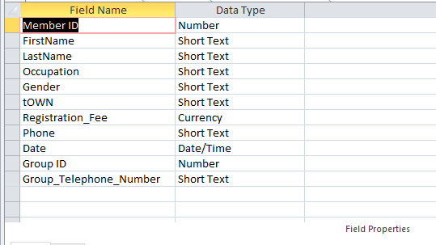 Figure 1 Individual Members Details

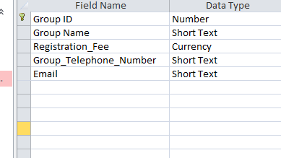

Figure 2 Group Member Details

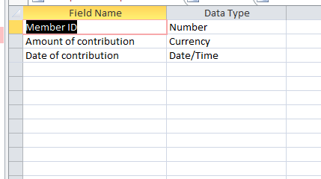

Figure 3 Contribution table/’

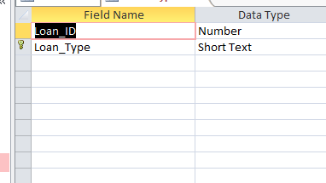

Figure 4 Loan type

Contribution table

|  |  |  |
| --- | --- | --- |
| Member ID | Amount of contribution | Date of contribution |
| 1 | 56000 | 7/7/2017 |
| 2 | 76000 | 7/7/2017 |
| 3 | 69000 | 7/7/2017 |
| 4 | 120000 | 7/7/2017 |
| 5 | 5000 | 7/7/2017 |
| 6 | 66700 | 7/7/2017 |
| 7 | 40000 | 7/7/2017 |
| 8 | 20000 | 7/7/2017 |
| 9 | 17000 | 7/7/2017 |
| 10 | 35000 | 7/7/2017 |

**Member details table**

|  |  |  |  |  |  |  |  |  |  |  |
| --- | --- | --- | --- | --- | --- | --- | --- | --- | --- | --- |
| Member ID | First name | Last name | occupation | gender | town | Registration fee | phone | date | Group ID | Group telephone number |
|  |  |  |  |  |  |  |  |  |  |  |
|  |  |  |  |  |  |  |  |  |  |  |
|  |  |  |  |  |  |  |  |  |  |  |
|  |  |  |  |  |  |  |  |  |  |  |
|  |  |  |  |  |  |  |  |  |  |  |
|  |  |  |  |  |  |  |  |  |  |  |
|  |  |  |  |  |  |  |  |  |  |  |
|  |  |  |  |  |  |  |  |  |  |  |
|  |  |  |  |  |  |  |  |  |  |  |
|  |  |  |  |  |  |  |  |  |  |  |

**Group Membership table**

|  |  |  |  |  |
| --- | --- | --- | --- | --- |
| Group ID | Group name | Registration fee | Group telephone no | Email |
| 0 | Tubbies | 5000 | 0721534647 | [Tubbies10@gmail.com](mailto:Tubbies10@gmail.com) |
| 1 | Nasa | 5000 | 0715191723 | [Nasa15@yahoo.com](mailto:Nasa15@yahoo.com) |
| 2 | Tibim | 5000 | 0700159905 | [Tibim45@gamil.com](mailto:Tibim45@gamil.com) |
| 3 | Jubilee | 5000 | 0713009901 | [Jubilee70@gmail.com](mailto:Jubilee70@gmail.com) |
| 4 | Arsenal | 5000 | 0700010344 | [Arsenal60@gmail.com](mailto:Arsenal60@gmail.com) |
| 5 | Composure | 5000 | 0701546633 | [Compusure33@gmail.com](mailto:Compusure33@gmail.com) |
| 6 | Maybach | 5000 | 0719175435 | [Maybach50@yahoo.com](mailto:Maybach50@yahoo.com) |
| 7 | Forza | 5000 | 0789562356 | [forza11@gmail.com](mailto:forza11@gmail.com) |
| 8 | Creed | 5000 | 0789126396 | [Creed47@yahoo.com](mailto:Creed47@yahoo.com) |
| 9 | Gamers | 5000 | 0720114455 | [Gamers39@gmail.com](mailto:Gamers39@gmail.com) |
| 10 | Noob | 5000 | 0742136989 | [Noob65@gmail.com](mailto:Noob65@gmail.com) |
| 11 | Kiboko | 5000 | 0789561477 | [Kiboko99@gmail.com](mailto:Kiboko99@gmail.com) |
| 12 | Kigongi | 5000 | 0756234599 | [Kigongi55@yahoo.com](mailto:Kigongi55@yahoo.com) |
| 13 | fcb | 5000 | 0745896320 | [Fcb09@gmail.com](mailto:Fcb09@gmail.com) |
| 14 | madrid | 5000 | 0719158559 | [Madrid25@yahoo.com](mailto:Madrid25@yahoo.com) |

**CHAPTER 4**

**System Design**

In this chapter we transformed requirement specifications into a logical view of the system.

We used system flowchart which allowed us to break processes down into individual events and to display shorthand form showing the sequential or logical relationship between them.

Some of the flowchart symbols we used are:

It shows a computerized process

Shows a decision in a flowchart

Used to show reports or documents

It triggers a chain of events to be undertaken

Disk master file

Used to show flow of direction

Connector

CHAPTER FIVE

SYSTEM FLOWCHARTS

Members Registration

PROGRAM DESIGN

Members Details Captured

Registration fee 5,000

Registration fee 2,000

Monthly Contribution

21,500 & 200 per share

Monthly contribution

<1000

Group Membership

Individual Membership

SHARES FLOWCHART

Shares

Group Member

Individual member

Defaulters 10% per month

Interest rate 0.8%

Repayment period

5yrs

Group loan

3 x group share

Interest rate 1%

Interest rate 1.2%

Repayment

< 3yrs

Repayment

< 4yrs

A x individual shares

3 x shares